University-Wide Housing Committee
Overview
April 30, 2013
New Haven is undergoing a period of immense change. Yale needs a university-wide housing policy to avoid the problems and exploit the opportunities this change presents. To do so, Yale should create a unified body, representing all of the major housing market stakeholders, to address particular housing-related concerns and to advise senior administration on long-term planning.
Creating a coherent, university-wide approach to housing issues has been checked by the diffusion of responsibility for aspects of housing policy across the university. For example, dealing with on-campus, graduate student dining options – a small slice of the university’s housing obligations – requires interacting with the following offices:
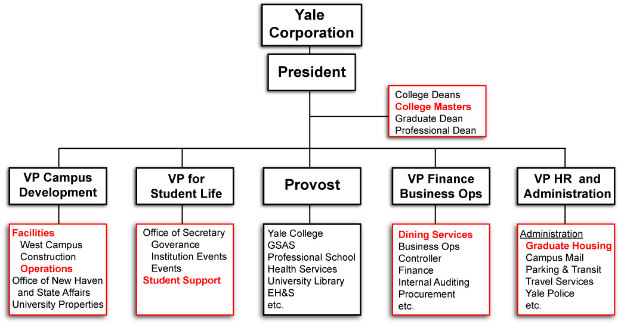
The diverse constituencies concerned with Yale housing – faculty, staff, graduate and professional students, undergraduates, participants in the Yale Homebuyer Program, Yale’s unions, the alders and other local government officials, neighborhood associations, local and regional developers, New Haven retailers, and others – no doubt have several points of shared interest. These interests can only be fully identified, weighed, and pursued if these various constituencies sit regularly at the same table.
We propose the creation of a University-Wide Housing Committee, directed to meet monthly and responsible for advising the administration on housing-related conflict resolution, investment, and planning. The following organizations should be given the opportunity to recommend committee members: Yale College Council, Graduate Student Assembly, Graduate and Professional Student Senate, Yale College Faculty, Graduate and Professional School Faculty, Local 34, Local 35, and Management and Professional staff. The following departments should also be represented: Graduate Housing, Undergraduate Housing/Council of Masters, University Properties, Office of New Haven and State Affairs, Yale Dining, Yale Security, and Yale Transit.
We believe that this collection of offices and personnel can successfully oversee Yale’s housing options, facilitate long-term integrated planning, and cultivate consensus within the university and the broader New Haven community.

